Please complete exercises 1 - 4, 6, 7, 9, 10, 12, and 14 for the StayWell Student Accommodation database on page 170 as indicated below.

1. For every property, list the management office number, address, monthly rent, owner number, owner’s first name, and owner’s last name.

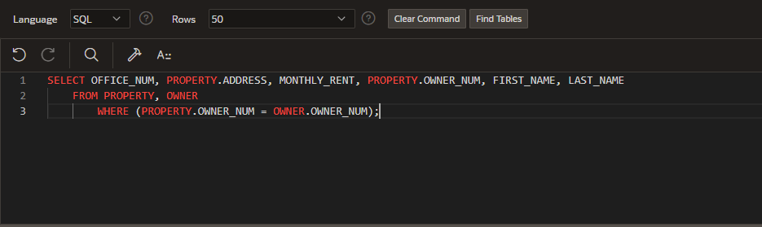

|  |  |  |  |  |  |
| --- | --- | --- | --- | --- | --- |
| OFFICE_NUM | ADDRESS | MONTHLY_RENT | OWNER_NUM | FIRST_NAME | LAST_NAME |
| 1 | 30 West Thomas Rd. | 1400 | BU106 | Ernest | Burke |
| 1 | 782 Queen Ln. | 1900 | AK102 | Ceyda | Aksoy |
| 1 | 9800 Sunbeam Ave. | 1200 | BI109 | Nicole | Bianchi |
| 1 | 105 North Illinois Rd. | 1650 | KO104 | Jakub | Kowalczyk |
| 1 | 887 Vine Rd. | 1160 | SI105 | Haydon | Sims |
| 1 | 8 Laurel Dr. | 2050 | MO100 | Elle-May | Moore |
| 2 | 447 Goldfield St. | 1700 | CO103 | Meerab | Cole |
| 2 | 594 Leatherwood Dr. | 2750 | KO104 | Jakub | Kowalczyk |
| 2 | 504 Windsor Ave. | 1050 | PA101 | Makesh | Patel |
| 2 | 891 Alton Dr. | 1600 | LO108 | Janine | Lopez |
| 2 | 9531 Sherwood Rd. | 1100 | JO110 | Ammarah | Jones |
| 2 | 2 Bow Ridge Ave. | 1700 | RE107 | Seth | Redman |

2. For every completed or open service request, list the property ID, description, and status.

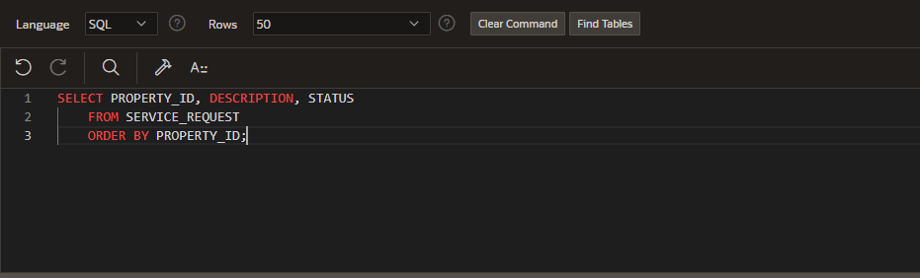

|  |  |  |
| --- | --- | --- |
| PROPERTY_ID | DESCRIPTION | STATUS |
| 11 | The second bedroom upstairs is not heating up at night. | Problem has been confirmed. central heating engineer has been scheduled. |
| 1 | A new strip light is needed for the kitchen. | Scheduled |
| 6 | The bathroom door does not close properly. | Service rep has confirmed issue. Scheduled to be refitted. |
| 2 | New outlet has been requested for the first upstairs bedroom. (There is currently no outlet). | Scheduled |
| 8 | New paint job requested for the common area (lounge). | Open |
| 4 | Shower is dripping when not in use. | Problem confirmed. Plumber has been scheduled. |
| 2 | Heating unit in the entrance smells like it's burning. | Service rep confirmed the issue to be dust in the heating unit. To be cleaned. |
| 9 | Kitchen sink does not drain properly. | Problem confirmed. Plumber scheduled. |
| 12 | New sofa requested. | Open |

3. For every service request for furniture replacement, list the property ID, management office number, address, estimated hours, spent hours, owner number, and owner’s last name.

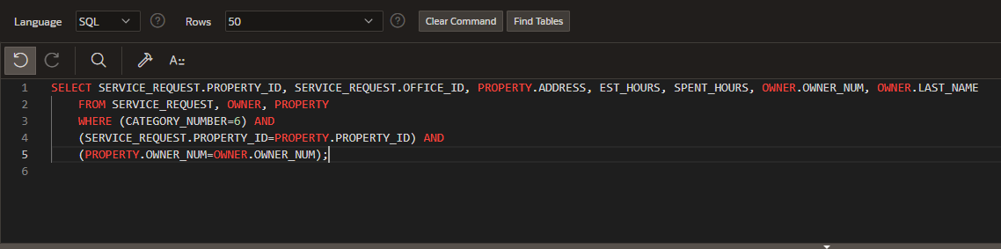

|  |  |  |  |  |  |  |
| --- | --- | --- | --- | --- | --- | --- |
| PROPERTY_ID | OFFICE_ID | ADDRESS | EST_HOURS | SPENT_HOURS | OWNER_NUM | LAST_NAME |
| 12 | 2 | 2 Bow Ridge Ave. | 2 | 0 | RE107 | Redman |

4. List the first and last names of all owners who own a two-bedroom property. Use the IN operator in your query.

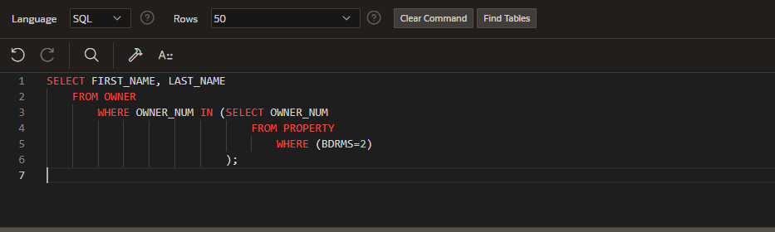

|  |  |
| --- | --- |
| FIRST_NAME | LAST_NAME |
| Nicole | Bianchi |
| Ammarah | Jones |
| Makesh | Patel |
| Haydon | Sims |

6. List the property IDs of any pair of properties that have the same number of bedrooms. For example, one pair would be property ID 2 and property ID 6, because they both have four bedrooms. The first property ID listed should be the major sort key and the second property ID should be the minor sort key.

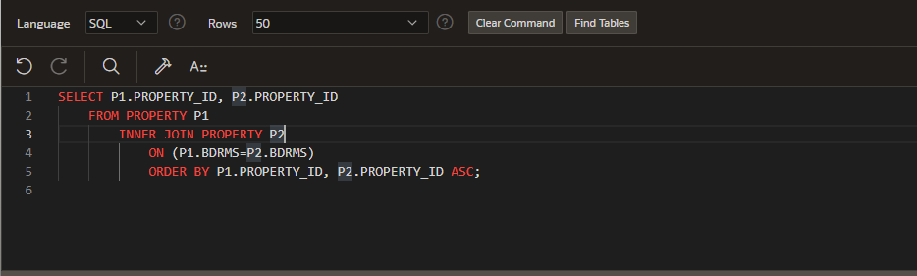

-Downloading the results as a csv wasn’t working, excel said accessibility issues.

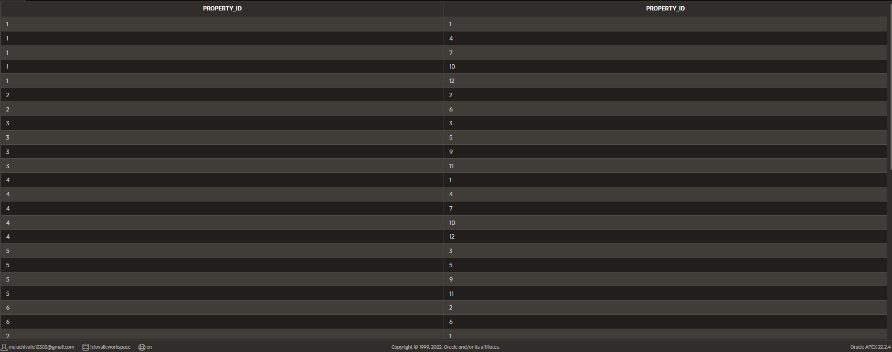

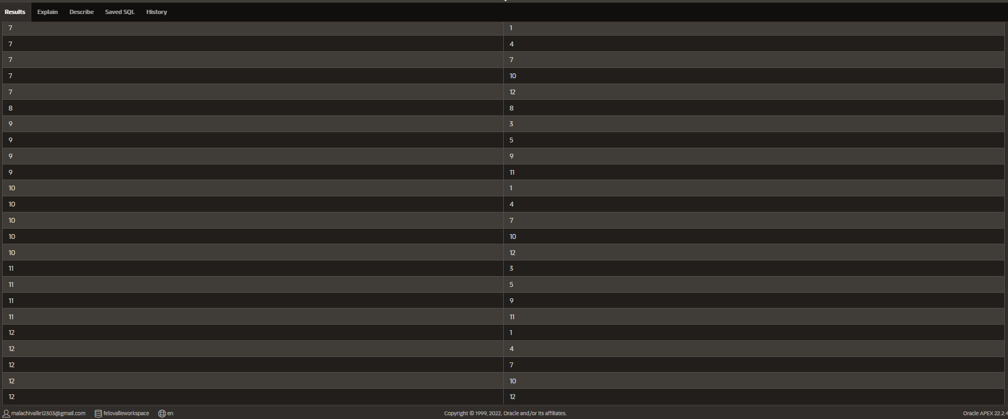

7. List the square footage, owner number, owner last name, and owner first name for each property managed by the Columbia City office.

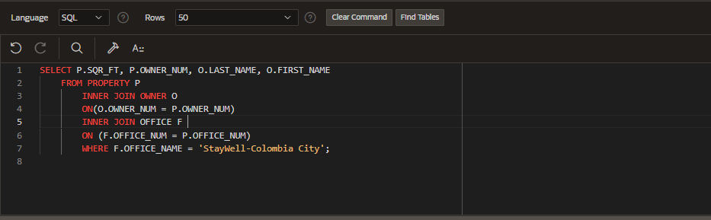

|  |  |  |  |
| --- | --- | --- | --- |
| SQR_FT | OWNER_NUM | LAST_NAME | FIRST_NAME |
| 1600 | BU106 | Burke | Ernest |
| 2100 | AK102 | Aksoy | Ceyda |
| 1005 | BI109 | Bianchi | Nicole |
| 1750 | KO104 | Kowalczyk | Jakub |
| 1125 | SI105 | Sims | Haydon |
| 2125 | MO100 | Moore | Elle-May |

9. List the office number, address, and monthly rent for properties whose owners live in Washington state or own two-bedroom properties.

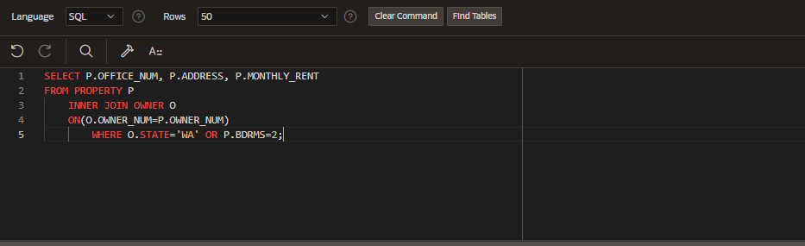

|  |  |  |
| --- | --- | --- |
| OFFICE_NUM | ADDRESS | MONTHLY_RENT |
| 1 | 782 Queen Ln. | 1900 |
| 1 | 9800 Sunbeam Ave. | 1200 |
| 1 | 105 North Illinois Rd. | 1650 |
| 1 | 887 Vine Rd. | 1160 |
| 2 | 447 Goldfield St. | 1700 |
| 2 | 594 Leatherwood Dr. | 2750 |
| 2 | 504 Windsor Ave. | 1050 |
| 2 | 891 Alton Dr. | 1600 |
| 2 | 9531 Sherwood Rd. | 1100 |
| 2 | 2 Bow Ridge Ave. | 1700 |

10. List the office number, address, and monthly rent for properties whose owners live in Washington state and own a two-bedroom property.

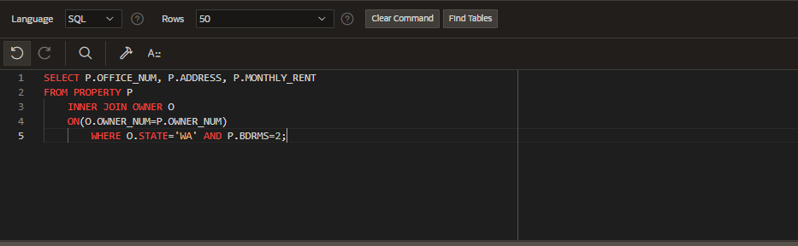

|  |  |  |
| --- | --- | --- |
| OFFICE_NUM | ADDRESS | MONTHLY_RENT |
| 2 | 504 Windsor Ave. | 1050 |
| 2 | 9531 Sherwood Rd. | 1100 |

12. Find the service ID and property ID for each service request whose estimated hours are greater than the number of estimated hours of at least one service request on which the category number is 5.

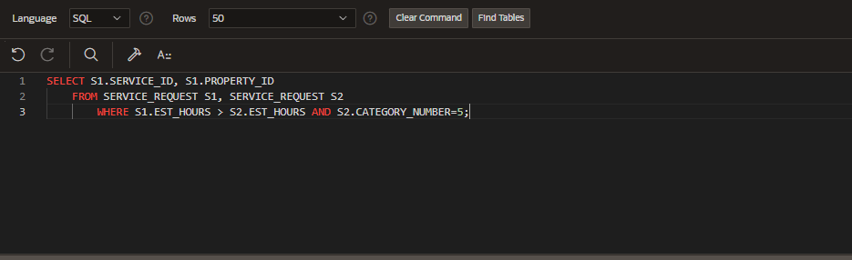

|  |  |
| --- | --- |
| SERVICE_ID | PROPERTY_ID |
| 5 | 8 |
| 6 | 4 |
| 8 | 9 |

14. List the address, square footage, owner number, service ID, number of estimated hours, and number of spent hours for each service request on which the category number is 4.

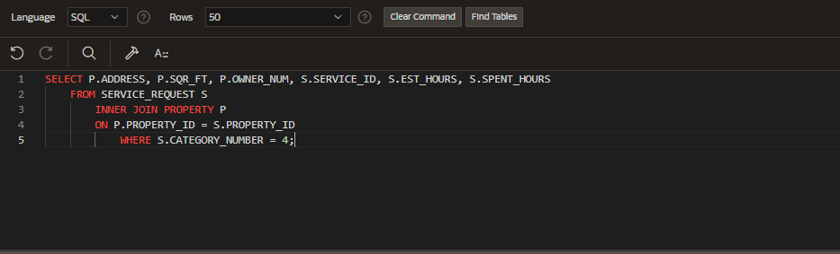

|  |  |  |  |  |  |
| --- | --- | --- | --- | --- | --- |
| ADDRESS | SQR_FT | OWNER_NUM | SERVICE_ID | EST_HOURS | SPENT_HOURS |
| 30 West Thomas Rd. | 1600 | BU106 | 2 | 1 | 0 |
| 782 Queen Ln. | 2100 | AK102 | 4 | 1 | 0 |